Experiment 18:
Source code:
#include <reg51.h>
sbit PWM = P1^0;
unsigned char count = 0;
void timer0_ISR(void) interrupt 1
{
TH0 = 0xFC;
TL0 = 0x66;
count++;
if (count <= 5)
{
PWM = 1; // ON period
}
else if (count <= 10)
{
PWM = 0; // OFF period
}
else
{
count = 0;
}
}

void main()
{
TMOD = 0x01; // Timer0 Mode 1
TH0 = 0xFC;
TL0 = 0x66;
EA = 1; // Enable global interrupt
ET0 = 1; // Enable Timer0 interrupt
TR0 = 1; // Start Timer0
while(1);
}
Output :
50% duty cycle:
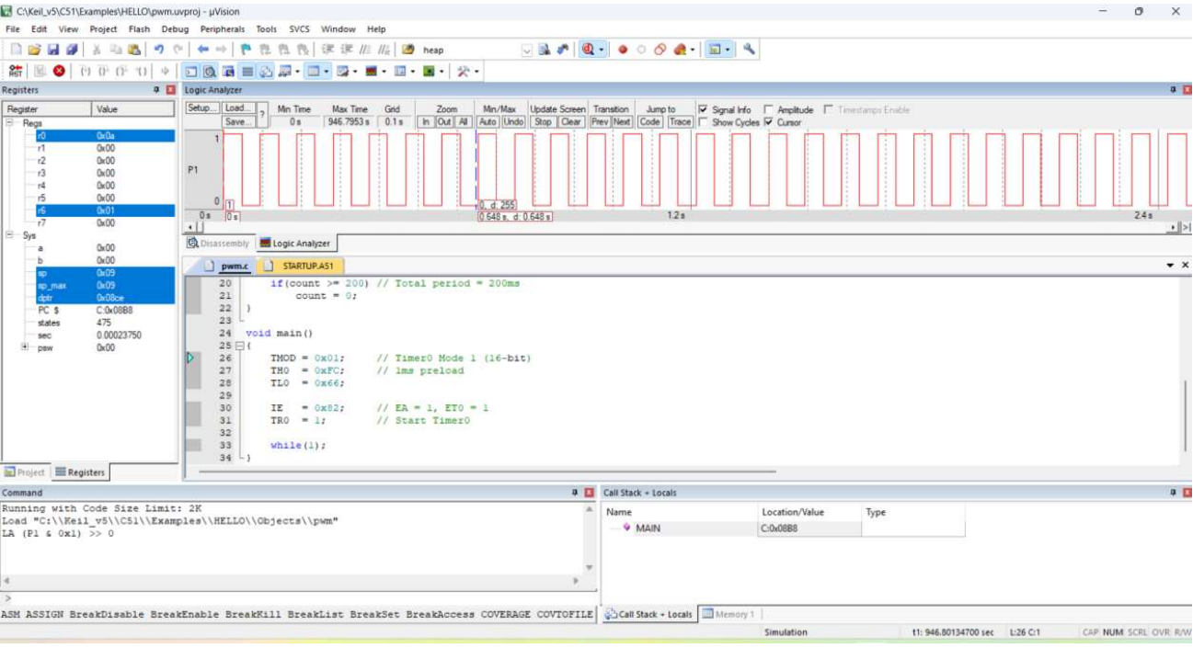

25% duty cycle:
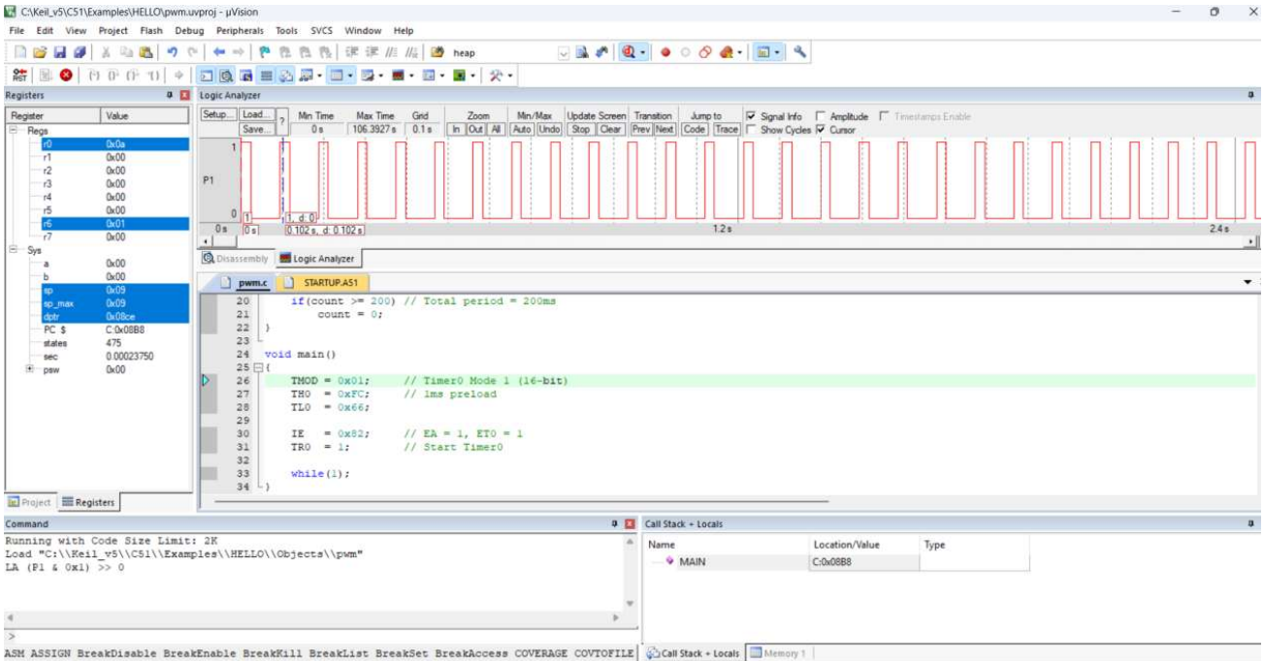
75% duty cycle:
